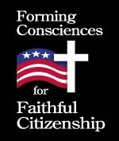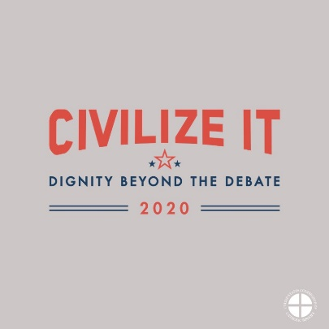

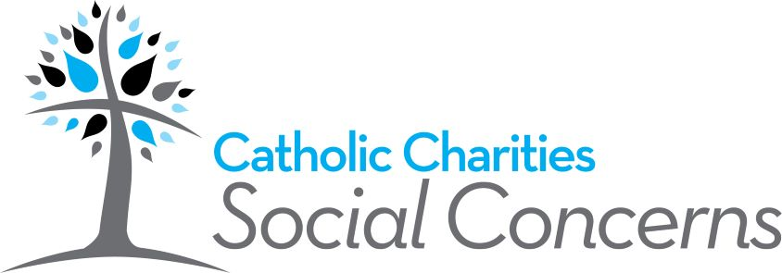

Week 1: Pray, Learn and Act as Faithful Citizens
Intro: On November the 3rd, the United States will hold the next elections. Much of the conversation in our communities, parishes, and families (not to mention on social media) is likely already influenced by the upcoming elections in our country. Opinions abound about for whom we should vote, which issues are important, and even what makes a faithful Catholic. As Catholics, we must also remember to be people who are hopeful, joyful, and loving, who always remember that Christ is King and we are building His kingdom, not our own, and that each person with whom we interact is made in the image and likeness of God. It is in this spirit, that we call on all Catholic citizens of the Archdiocese of Indianapolis to commit ourselves to deeper prayer, study, and action surrounding how we live our faith in this moment in the history of our country. The ministries of Human Life and Dignity and Catholic Charities- Social Concerns will collaborate to offer the following each week for the next seven weeks: one prayer, one informational paragraph, and one action you can take to spiritually prepare yourself for the November elections.
Pray: Make Me an Instrument of Your Peace: A Prayer for Civility
Lord, make me an instrument of your peace. Where uncivil words prevail, show me how to model love. Help me remember the God-given dignity of all and invite others to do the same. Show me how to build bridges and not walls and see first what unites us rather than how we diverge. Let me seek to understand before asking to be understood. Give me a listening heart filled with empathy and compassion. May I be clear in sharing my own position and respectful and civil in describing those of others. Let me never tolerate hateful ideas. May I invite all to charity and love. Lord, help me to imitate your compassion and mercy. Make me an instrument of your peace. Amen.
Inspired by Nine Rules for Civility from the Catholic Tradition, Bishop Zubik
Learn
Jesus uses the parable of the Good Samaritan to answer a question that is both searing and simple: “Who is my neighbor?” (Luke 10: 29). Our familiarity with this parable makes it easy for us now to identify as “neighbor” those on the margins of our society such as those experiencing homelessness or poverty. But how often do we see our neighbor in the person who disagrees with us? As Catholics, our strong tradition of social teaching compels us to be actively engaged in the building up of our communities. This is achieved by being involved in the political process—and yet today, many shy away from such involvement because our national and local conversations are filled with vitriol and harsh language, often directed at people themselves. When personal attacks replace honest debate, no one wins. This kind of attack, no matter the reason, only serves to further divide our communities. What is needed is good, honest, civil dialogue. This means that we must treat everyone as worthy of being at the table, worthy of our respect, and worthy of being heard. In short, it means treating everyone as our neighbor.
Act: Take the Civilize It Pledge
Take the pledge below as an individual, family, or community. Anyone and everyone can commit
together to honoring human dignity through civil conversation.
I pledge:
Civility
To recognize the human dignity of those with whom I disagree, treat others with respect,
and rise above attacks when directed at me.
Clarity
To root my political viewpoints in the Gospel and a well- formed conscience, which involves
prayer, conversation, study and listening. I will stand up for my convictions and speak out
when I witness language that disparages others' dignity, while also listening and seeking to
understand others’ experiences.
Compassion
To encounter others with a tone and posture which affirms that I honor the dignity of
others and invites others to do the same. I will presume others’ best intentions and listen to
their stories with empathy. I will strive to understand before seeking to be understood.

Signature_________________________________________________ Date______________
For more information, including tips for engaging in civil dialogue, please visit:
https://www.civilizeit.org
